. 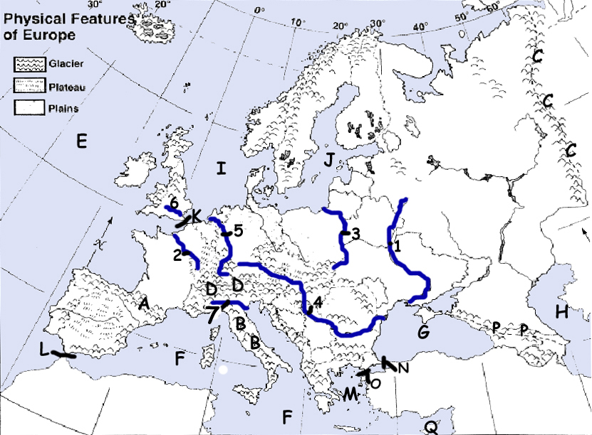

**B**

**E**

1. Scandinavian peninsula
2. Iberian Peninsula
3. Rhine River
4. Alps
5. Mediterranean Sea
6. Danube River
7. Ural Mountains
8. English Channel
9. Pyrenees Mountains
10. European Plain

**G**

**I**

**C**

**D**

**J**

**F**

**A**

**H**